**WEEK 3**

**Exercise 1: Configuring a Basic Spring Application**

**CODING:**

**BookRepository.java**

**package** com.library.repository;

**public** **class** BookRepository {

**public** **void** saveBook(String name) {

System.***out***.println("Saving book: " + name);

}

}

**BookService.java**

**package** com.library.service;

**import** com.library.repository.BookRepository;

**public** **class** BookService {

**private** BookRepository bookRepository;

**public** **void** setBookRepository(BookRepository bookRepository) {

**this**.bookRepository = bookRepository;

}

**public** **void** addBook(String name) {

bookRepository.saveBook(name);

}

}

**LibraryApp.java**

package com.library.main;

import org.springframework.context.ApplicationContext;

import org.springframework.context.support.ClassPathXmlApplicationContext;

import com.library.service.BookService;

public class LibraryApp {

public static void main(String[] args) {

ApplicationContext context = new ClassPathXmlApplicationContext("applicationContext.xml");

BookService bookService = context.getBean("bookService", BookService.class);

bookService.addBook("Spring in Action");

}

}

**ApplicationContext.xml:**

<?xml version=*"1.0"* encoding=*"UTF-8"*?>

<beans xmlns=*"http://www.springframework.org/schema/beans"*

xmlns:xsi=*"http://www.w3.org/2001/XMLSchema-instance"*

xsi:schemaLocation=*"*

*http://www.springframework.org/schema/beans*

*https://www.springframework.org/schema/beans/spring-beans.xsd"*>

<!-- Repository bean -->

<bean id=*"bookRepository"*

class=*"com.library.repository.BookRepository"* />

<!-- Service bean -->

<bean id=*"bookService"*

class=*"com.library.service.BookService"*>

<property name=*"bookRepository"* ref=*"bookRepository"*/>

</bean>

</beans>

OUTPUT:

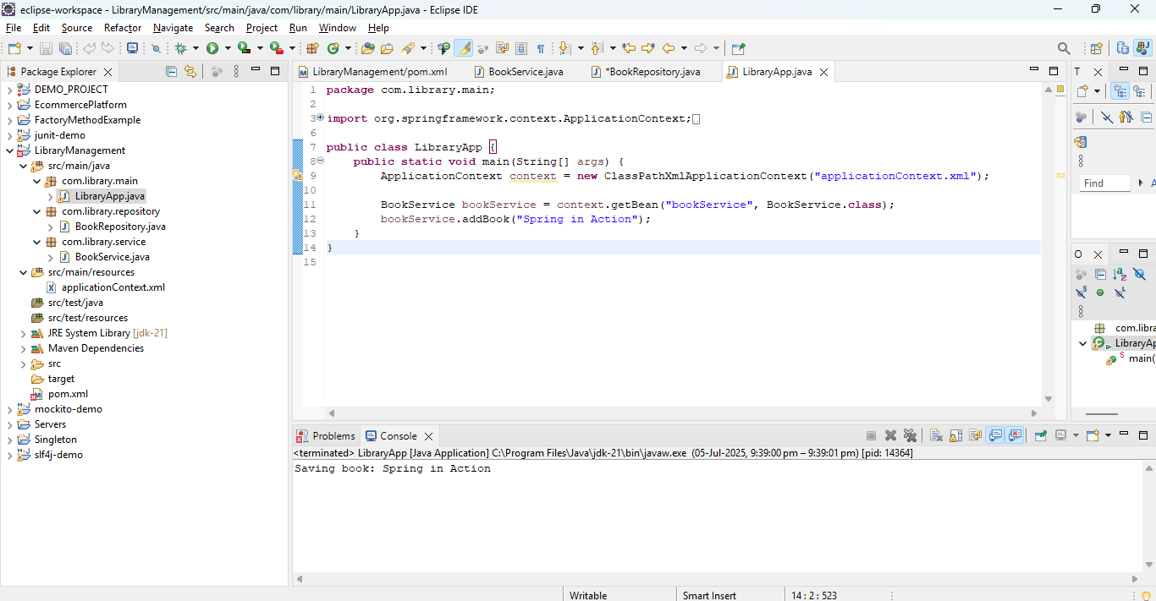

**Exercise 2: Implementing Dependency Injection**

CODING:

**BookService.java**

**package** com.library.service;

**import** com.library.repository.BookRepository;

**public** **class** BookService {

**private** BookRepository bookRepository;

**public** **void** setBookRepository(BookRepository bookRepository) {

**this**.bookRepository = bookRepository;

}

**public** **void** addBook(String title) {

bookRepository.saveBook(title);

}

}

**BookRepository.java**

**package** com.library.repository;

**public** **class** BookRepository {

**public** **void** saveBook(String name) {

System.***out***.println("Saving book: " + name);

}

}

**LibraryApp.java**

package com.library.main;

import org.springframework.context.ApplicationContext;

import org.springframework.context.support.ClassPathXmlApplicationContext;

import com.library.service.BookService;

public class LibraryApp {

public static void main(String[] args) {

ApplicationContext context = new ClassPathXmlApplicationContext("applicationContext.xml");

BookService bookService = context.getBean("bookService", BookService.class);

bookService.addBook("Spring in Action");

}

}

**ApplicationContext.xml:**

<?xml version=*"1.0"* encoding=*"UTF-8"*?>

<beans xmlns=*"http://www.springframework.org/schema/beans"*

xmlns:xsi=*"http://www.w3.org/2001/XMLSchema-instance"*

xsi:schemaLocation=*"*

*http://www.springframework.org/schema/beans*

*https://www.springframework.org/schema/beans/spring-beans.xsd"*>

<!-- Repository bean -->

<bean id=*"bookRepository"*

class=*"com.library.repository.BookRepository"* />

<!-- Service bean -->

<bean id=*"bookService"*

class=*"com.library.service.BookService"*>

<property name=*"bookRepository"* ref=*"bookRepository"*/>

</bean>

</beans>

**OUTPUT:**

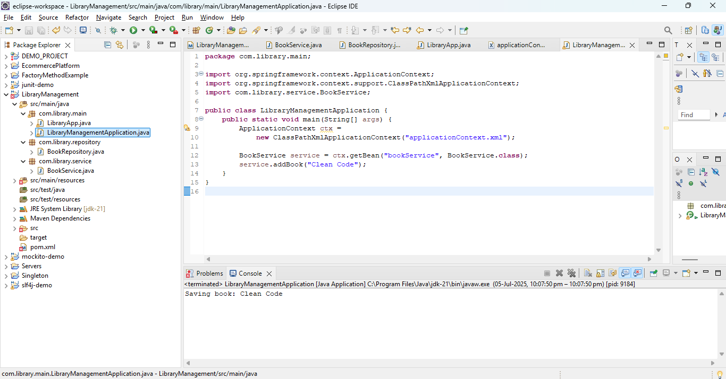

**Exercise 4: Creating and Configuring a Maven Project**

**CODING:**

**BookService.java**

**package** com.library.service;

**import** com.library.repository.BookRepository;

**public** **class** BookService {

**private** BookRepository bookRepository;

**public** **void** setBookRepository(BookRepository bookRepository) {

**this**.bookRepository = bookRepository;

}

**public** **void** addBook(String title) {

bookRepository.saveBook(title);

}

}

**BookRepository.java**

**package** com.library.repository;

**public** **class** BookRepository {

**public** **void** saveBook(String name) {

System.***out***.println("Saving book: " + name);

}

}

**LibraryApp.java**

package com.library.main;

import org.springframework.context.ApplicationContext;

import org.springframework.context.support.ClassPathXmlApplicationContext;

import com.library.service.BookService;

public class LibraryApp {

public static void main(String[] args) {

ApplicationContext context = new ClassPathXmlApplicationContext("applicationContext.xml");

BookService bookService = context.getBean("bookService", BookService.class);

bookService.addBook("Spring in Action");

}

}

**ApplicationContext.xml:**

<?xml version=*"1.0"* encoding=*"UTF-8"*?>

<beans xmlns=*"http://www.springframework.org/schema/beans"*

xmlns:xsi=*"http://www.w3.org/2001/XMLSchema-instance"*

xsi:schemaLocation=*"*

*http://www.springframework.org/schema/beans*

*https://www.springframework.org/schema/beans/spring-beans.xsd"*>

<!-- Repository bean -->

<bean id=*"bookRepository"*

class=*"com.library.repository.BookRepository"* />

<!-- Service bean -->

<bean id=*"bookService"*

class=*"com.library.service.BookService"*>

<property name=*"bookRepository"* ref=*"bookRepository"*/>

</bean>

</beans>

**Pom.xml**

<project xmlns="http://maven.apache.org/POM/4.0.0"

xmlns:xsi="http://www.w3.org/2001/XMLSchema-instance"

xsi:schemaLocation="http://maven.apache.org/POM/4.0.0 http://maven.apache.org/xsd/maven-4.0.0.xsd">

<modelVersion>4.0.0</modelVersion>

<groupId>com.library</groupId>

<artifactId>LibraryManagement</artifactId>

<version>1.0.0</version>

<packaging>jar</packaging>

<properties>

<java.version>1.8</java.version>

<spring.version>5.3.32</spring.version>

<project.build.sourceEncoding>UTF-8</project.build.sourceEncoding>

</properties>

<dependencies>

<dependency>

<groupId>org.springframework</groupId>

<artifactId>spring-context</artifactId>

<version>${spring.version}</version>

</dependency>

<dependency>

<groupId>org.springframework</groupId>

<artifactId>spring-aop</artifactId>

<version>${spring.version}</version>

</dependency>

<dependency>

<groupId>org.springframework</groupId>

<artifactId>spring-webmvc</artifactId>

<version>${spring.version}</version>

</dependency>

<dependency>

<groupId>org.slf4j</groupId>

<artifactId>slf4j-simple</artifactId>

<version>2.0.13</version>

</dependency>

<dependency>

<groupId>junit</groupId>

<artifactId>junit</artifactId>

<version>4.13.2</version>

<scope>test</scope>

</dependency>

</dependencies>

<build>

<plugins>

<plugin>

<groupId>org.apache.maven.plugins</groupId>

<artifactId>maven-compiler-plugin</artifactId>

<version>3.11.0</version>

<configuration>

<source>${java.version}</source>

<target>${java.version}</target>

</configuration>

</plugin>

</plugins>

</build>

</project>

**Spring Data JPA - Quick Example**

**Software Pre-requisites**

• MySQL Server 8.0

• MySQL Workbench 8

• Eclipse IDE for Enterprise Java Developers 2019-03 R

• Maven 3.6.2

**Step 1:** Create a Eclipse Project using Spring Initializer

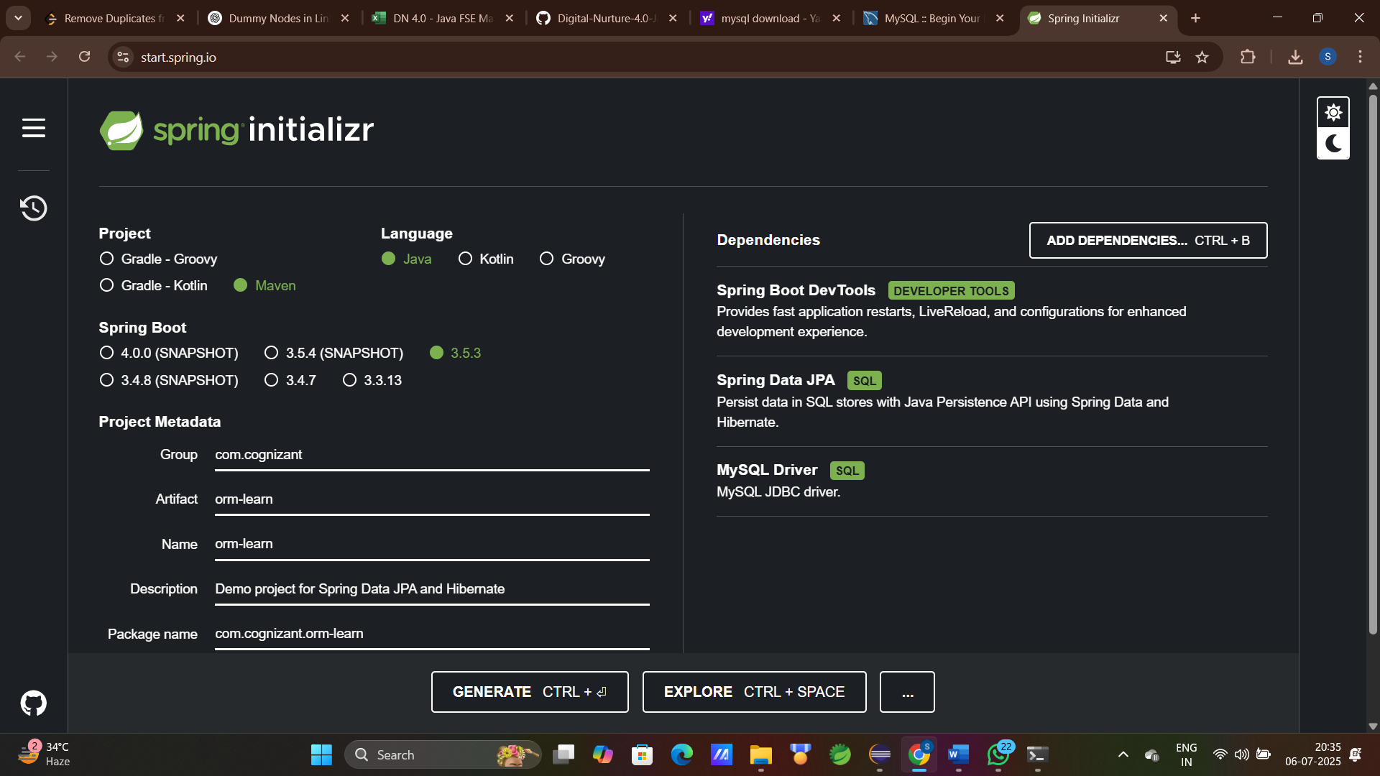

**Step 2:** Extract the zip in root folder to Eclipse Workspace and Import the project in Eclipse

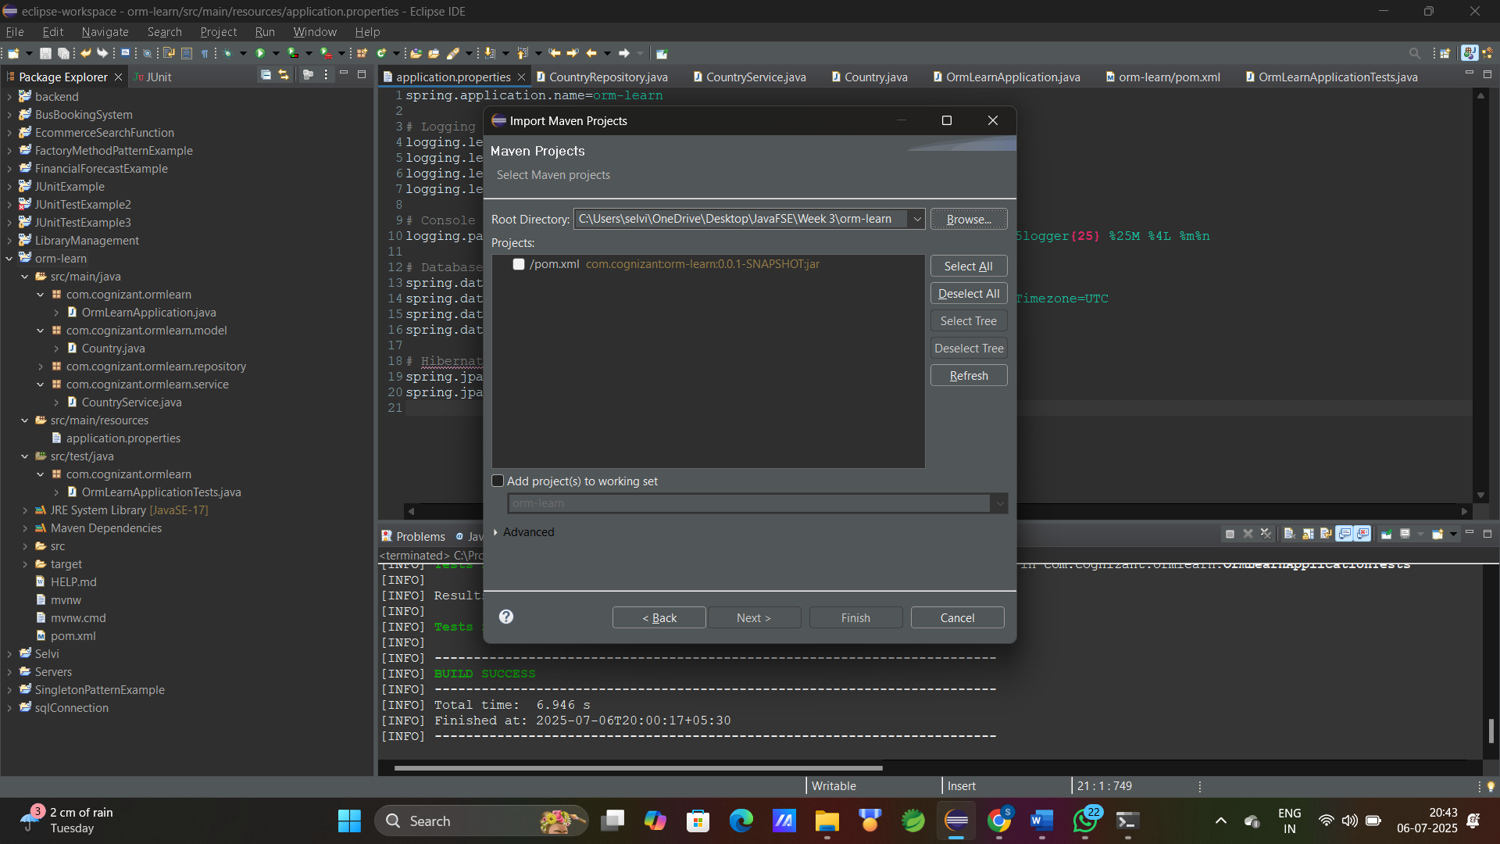

**Step 3:** open MySQL client and create schema

Command : mysql> create schema ormlearn;  
 mysql> use ormlearn;  
create table country and insert values

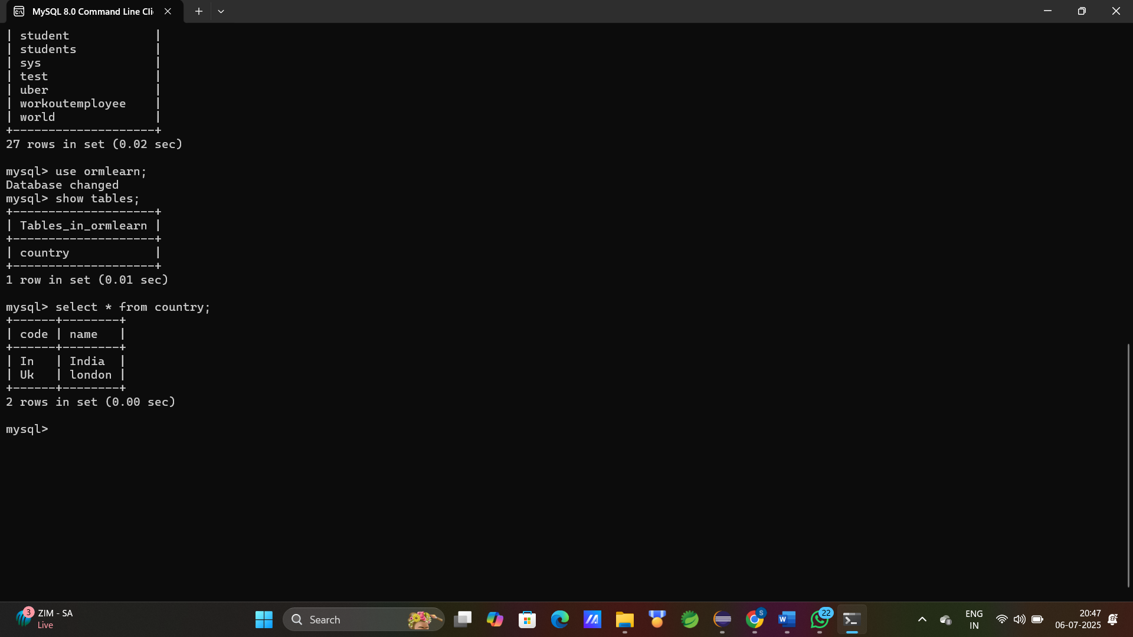

**Step 4:** Setup application.properties and pom.xml(add required dependencies)

application.properties

spring.application.name=orm-learn

logging.level.org.springframework=info

logging.level.com.cognizant=debug

logging.level.org.hibernate.SQL=trace

logging.level.org.hibernate.type.descriptor.sql=trace

logging.pattern.console=%d{dd-MM-yy} %d{HH:mm:ss.SSS} %-20.20thread %5p %-25.25logger{25} %25M %4L %m%n

spring.datasource.driver-class-name=com.mysql.cj.jdbc.Driver

spring.datasource.url=jdbc:mysql://localhost:3306/ormlearn?useSSL=false&serverTimezone=UTC

spring.datasource.username=root

spring.datasource.password=root

spring.jpa.hibernate.ddl-auto=validate

spring.jpa.database-platform=org.hibernate.dialect.MySQLDialect

pom.xml

<?xml version="1.0" encoding="UTF-8"?>

<project xmlns="http://maven.apache.org/POM/4.0.0" xmlns:xsi="http://www.w3.org/2001/XMLSchema-instance"

xsi:schemaLocation="http://maven.apache.org/POM/4.0.0 https://maven.apache.org/xsd/maven-4.0.0.xsd">

<modelVersion>4.0.0</modelVersion>

<parent>

<groupId>org.springframework.boot</groupId>

<artifactId>spring-boot-starter-parent</artifactId>

<version>3.4.8-SNAPSHOT</version>

<relativePath/> <!-- lookup parent from repository -->

</parent>

<groupId>com.cognizant</groupId>

<artifactId>orm-learn</artifactId>

<version>0.0.1-SNAPSHOT</version>

<name>orm-learn</name>

<description>Demo project for Spring Boot JPA and Hibernate</description>

<url/>

<licenses>

<license/>

</licenses>

<developers>

<developer/>

</developers>

<scm>

<connection/>

<developerConnection/>

<tag/>

<url/>

</scm>

<properties>

<java.version>17</java.version>

</properties>

<dependencies>

<dependency>

<groupId>org.springframework.boot</groupId>

<artifactId>spring-boot-starter-data-jpa</artifactId>

</dependency>

<dependency>

<groupId>org.springframework.boot</groupId>

<artifactId>spring-boot-devtools</artifactId>

<scope>runtime</scope>

<optional>true</optional>

</dependency>

<dependency>

<groupId>com.mysql</groupId>

<artifactId>mysql-connector-j</artifactId>

<scope>runtime</scope>

</dependency>

<dependency>

<groupId>org.springframework.boot</groupId>

<artifactId>spring-boot-starter-test</artifactId>

<scope>test</scope>

</dependency>

</dependencies>

<build>

<plugins>

<plugin>

<groupId>org.springframework.boot</groupId>

<artifactId>spring-boot-maven-plugin</artifactId>

</plugin>

</plugins>

</build>

<repositories>

<repository>

<id>spring-snapshots</id>

<name>Spring Snapshots</name>

<url>https://repo.spring.io/snapshot</url>

<releases>

<enabled>false</enabled>

</releases>

</repository>

</repositories>

<pluginRepositories>

<pluginRepository>

<id>spring-snapshots</id>

<name>Spring Snapshots</name>

<url>https://repo.spring.io/snapshot</url>

<releases>

<enabled>false</enabled>

</releases>

</pluginRepository>

</pluginRepositories>

</project>

**Step 5:** create new package for model

Path: src/main/java/com.cognizant.ormlearn.model.Country

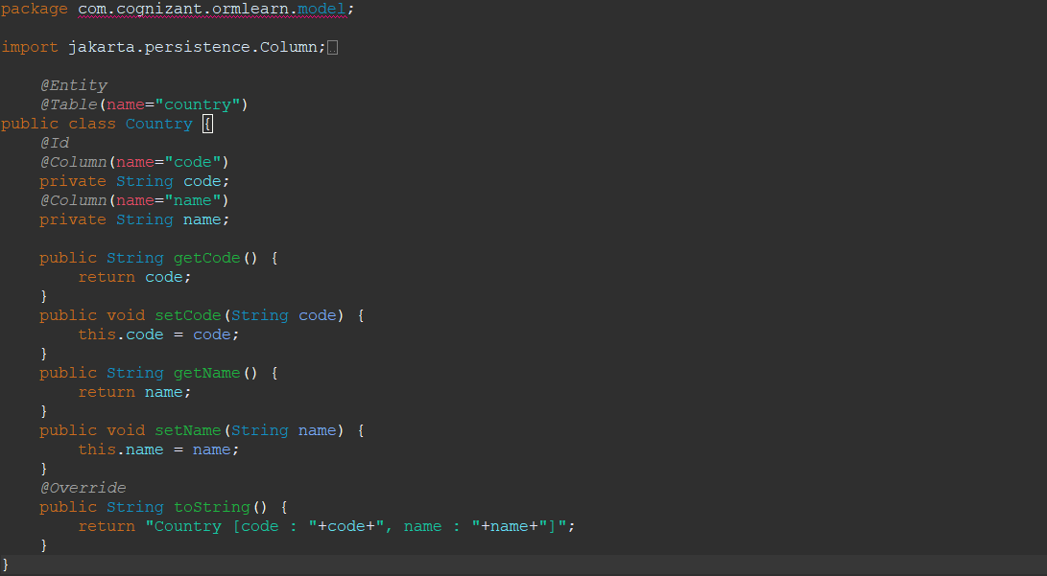

**Step 6:** create new package for Repository

Path: src/main/java/com.cognizant.ormlearn.repository.CountryRepository

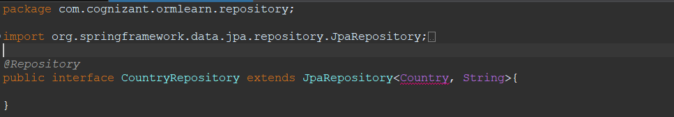

**Step 7:** create new package for Service

Path: src/main/java/com.cognizant.ormlearn.service.CountryService

package com.cognizant.ormlearn.service;

import java.util.List;

import org.springframework.beans.factory.annotation.Autowired;

import org.springframework.stereotype.Service;

import com.cognizant.ormlearn.model.Country;

import com.cognizant.ormlearn.repository.CountryRepository;

import jakarta.transaction.Transactional;

*@Service*

public class CountryService {

*@Autowired*

private CountryRepository countryRepository;

*@Transactional*

public List<Country>getAllCountries(){

return countryRepository.findAll();

}

}

**Step 8:** java class for OrmLearnApplication

Path: src/main/java/com.cognizant.ormlearn.OrmLearnApplication

package com.cognizant.ormlearn;

import java.util.List;

import org.slf4j.Logger;

import org.slf4j.LoggerFactory;

import org.springframework.boot.SpringApplication;

import org.springframework.context.ApplicationContext;

import org.springframework.boot.autoconfigure.SpringBootApplication;

import com.cognizant.ormlearn.model.Country;

import com.cognizant.ormlearn.service.CountryService;

*@SpringBootApplication*

public class OrmLearnApplication {

private static final Logger ***LOGGER*** = LoggerFactory.*getLogger*(OrmLearnApplication.class);

private static CountryService *countryService*;

public static void main(String[] args) {

ApplicationContext context = SpringApplication.*run*(OrmLearnApplication.class, args);

*countryService* = context.getBean(CountryService.class);

***LOGGER***.info("Inside main");

*testGetAllCountries*();

}

private static void testGetAllCountries() {

***LOGGER***.info("Start");

List<Country> countries = *countryService*.getAllCountries();

***LOGGER***.debug("countries={}", countries);

***LOGGER***.info("End");

}

}

**Step 9:** java class for OrmLearnApplicationTest

Path: src/test/java/com.cognizant.ormlearn.OrmLearnApplicationTest

package com.cognizant.ormlearn;

import org.junit.jupiter.api.Test;

import org.springframework.boot.test.context.SpringBootTest;

*@SpringBootTest*(classes = OrmLearnApplication.class)

public class OrmLearnApplicationTests {

*@Test*

void contextLoads() {

}

}

**Output:**

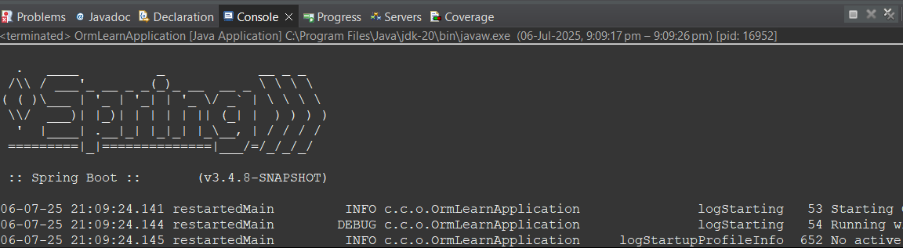

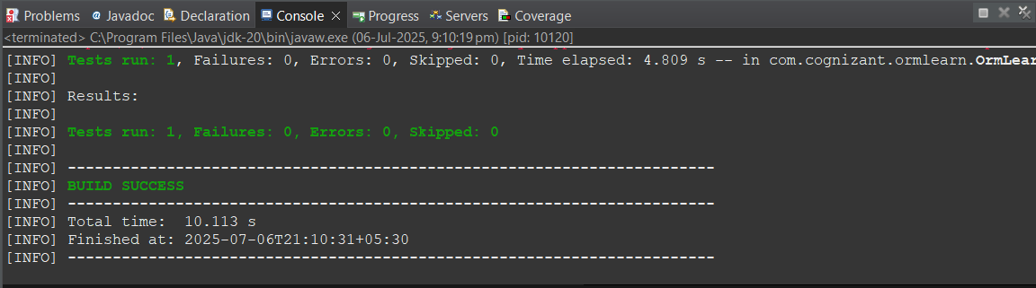

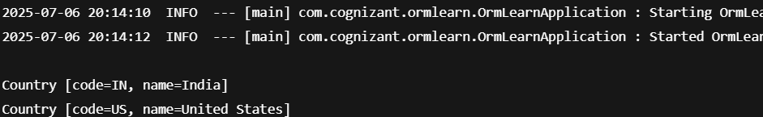

**Difference between JPA, Hibernate and Spring Data JPA**

CODING:

**Employee.java:**

package com.example.demo.entity;

import jakarta.persistence.*;

@Entity

public class Employee {

@Id

@GeneratedValue(strategy = GenerationType.IDENTITY)

private Integer id;

private String name;

private String department;

private double salary;

public Employee() {}

public Employee(String name, String department, double salary) {

this.name = name;

this.department = department;

this.salary = salary;

}

}

**EmployeeRepository.java**

package com.example.demo.repository;

import com.example.demo.entity.Employee;

import org.springframework.data.jpa.repository.JpaRepository;

public interface EmployeeRepository extends JpaRepository<Employee, Integer> {

}

**EmployeeService.java**

package com.example.demo.service;

import com.example.demo.entity.Employee;

import com.example.demo.repository.EmployeeRepository;

import org.springframework.beans.factory.annotation.Autowired;

import org.springframework.stereotype.Service;

import org.springframework.transaction.annotation.Transactional;

@Service

public class EmployeeService {

@Autowired

private EmployeeRepository employeeRepository;

@Transactional

public void addEmployee(Employee employee) {

employeeRepository.save(employee);

}

}

**DemoApplication.java**

package com.example.demo;

import com.example.demo.entity.Employee;

import com.example.demo.service.EmployeeService;

import org.springframework.beans.factory.annotation.Autowired;

import org.springframework.boot.CommandLineRunner;

import org.springframework.boot.SpringApplication;

import org.springframework.boot.autoconfigure.SpringBootApplication;

@SpringBootApplication

public class DemoApplication implements CommandLineRunner {

@Autowired

private EmployeeService employeeService;

public static void main(String[] args) {

SpringApplication.run(DemoApplication.class, args);

}

@Override

public void run(String... args) throws Exception {

Employee emp = new Employee("Divya", "IT", 50000);

employeeService.addEmployee(emp);

System.out.println("Employee added!");

}

}

**DemoApplicationTests.java**

package com.example.demo;

import org.junit.jupiter.api.Test;

import org.springframework.boot.test.context.SpringBootTest;

@SpringBootTest

class DemoApplicationTests {

@Test

void contextLoads() {

}

}

**OUTPUT:**

